## Merchant Name: Blumira Implementation POC: Royce *(IM to fill)* CX POC: *[IMP to Add]*

### 

### 

| Notes Sections   *(AE to fill if they have, Implementation to be completion DRI on handoff)*   * Info on how merchant bills   Two Revenue Streams: Direct Model and MSP Reseller Model  Parent–child and reseller billing models across 4–5 distinct product lines and multiple customer hierarchies. Direct Model is 1:1 relationship with the customer Usage (PxQ, Tiers, Drawdown) - experimenting with new pricing too  1) What is the merchant temperament?  👤 Edward Sawyer  Role: CFO, Executive Sponsor, Champion  Responsibilities: Oversees financial operations, including billing efficiency and strategic vendor selection.  Focus Areas: Time/cost savings, minimizing manual workflows, and enabling scale.  Temperament: Pragmatic, direct, open to collaboration; moves quickly when there’s clear ROI.  👤 Michael Kellar  Role: Operations Lead / Deal Champion  Responsibilities: Leads procurement, billing process design, and system integration planning.  Focus Areas: Automation, integration with HubSpot/Campfire/Stripe, and usage-based billing flexibility.  Temperament: Analytical, solutions-oriented, fast-moving; values responsiveness and clarity. **👤 Chris** **Role:** Engineering and Sales **Responsibilities:** Evaluating API capabilities, data integration architecture, and HubSpot/Stripe connectivity. **Cares About:** Simplicity of API design, real-time data syncs, and engineering workload. Removing himself from the Billing Process **Temperament:** Technical, detail-focused, concise; asks sharp questions to validate implementation risk.  **👤 Faith**  **Role:** Revenue Operations / Billing Execution, Cross Functional Leader  **Responsibilities:** Likely handles monthly billing cycles, reconciliations, and tool workflows.  **Cares About:** Reducing manual work, avoiding billing mistakes, streamlining AR processes.  **Temperament:** Thoughtful, tactical, measured; oriented around usability and operational pain.  3) What are the Tabs features that the key POC cares about?  Replace manual invoicing by automating workflows that currently take two senior team members four days each month.  Support parent–child and reseller billing models across 4–5 distinct product lines and multiple customer hierarchies.  Enable flexible, usage-based billing for AI features launching this quarter and future metered offerings.  Shift billing logic from manual field entry to contract-based extraction to reduce errors and reliance on sales reps.  Scale AR infrastructure to handle 50% YoY growth and streamline future reporting for revenue, collections, and customer health.  Integrate seamlessly with HubSpot (CRM), Stripe (payments), and Anrok (tax) to ensure data consistency and workflow automation. Manual Upload of data to Campfire (ERP) |
| --- |

### Billing model *(Entire Section: Implementation to fill section)*

* Are there unique things about the customer creation process for this merchant?
* Information on how merchant bills
* How contract is broken up
* One off things to know about the merchant

### Contract Processing Steps *(Entire Section: Implementation/Success to fill Post-Go Live)*

1. Steps to process

Customer

* Please make sure that the billing contact information matches the contract
* The customer may already exist but we should double check that their email address and contact are the same as what’s in the contract. We should update the billing information if it isn’t

2 contract types:

**MSP Plan**  
 BT are in MSP Plan Options table; example below

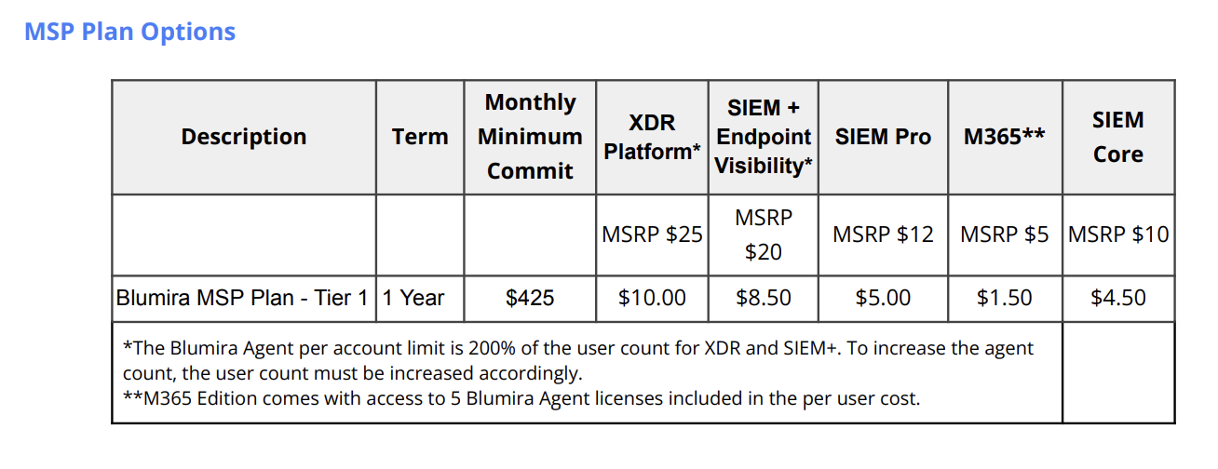

* Every column besides “Monthly Minimum Commit” should be a unit BT
  + Use the Unit price underneath the MSRP price row
  + Sometimes there is a discount row listed in the table - in this case, please reflect this discount inline on the BT
  + E.g. for XDR Platform, value is $10 → if there was an in- discount of $x → final value would be $10 - $[x]
* If a certain column has price “Free”, no need to create a BT

Go to MSP Plan section of this MIS and follow those instructions

**Services**



* Only BT you need to create are the two line items referencing the annual and total cost column for the amount to be billed
  + Discount to “annual cost” should be shown in line in the BT
  + No need to create usage BT for the “discounted list cost - per license - per year” column
  + No usage ai required
  + Example contract e8f93d31-de9b-485c-9cd7-4a6d21412bd2

Go to Services section of this MIS and follow those instructions

### MSP Plan

* **Revenue Schedule**
  + Use the 1st of the month for “Monthly Billing Begins”
  + In the table labeled “Selected MSP Billing Plan”



* **Months of Service**
  + Use number of months in the stated “term” column
* **Item Name**
  + use the title of the column e.g. “XDR Platform*” and “SIEM+ Endpoint Visibility”
* **Item Description**
  + Use the description e.g. “Blumira MSP Plan - Tier 1”
* **Billing Type**
  + Unit
    - **Do not** create tier unit BT even if contract notes an “included” amount of users
* **Total Price**
  + Use the Unit price underneath the MSRP price row
    - So for XDR Platform, the total value would be $10
  + Sometimes there is a discount row listed in the table - in this case, please reflect this discount inline on the BT
    - E.g. for XDR Platform, value is $10 → if there was an in- discount of $x → final value would be $10 - $[x]
* **Event to track**
  + Match item name
* **Billing Start Date**
  + Same as service start date
* **Period**
  + Based on the term and frequency
* **Frequency**
  + Most likely 1 month - double check payment terms (example below)



* **Net terms**
  + Double check payment terms, default to 30 if nothing is stated
  + “Due upon receipt” = net terms 0
* **Billing Timing**
  + Bill first of next period (arrears)
* **CREATE USAGE AI**
  + “Has Minimum”
  + Usage name: “Minimum Monthly Commitment”
  + Include **all** products
    - **Please SELECT all products individually. The default does not actually select all the products (see below) but these should all be checked**

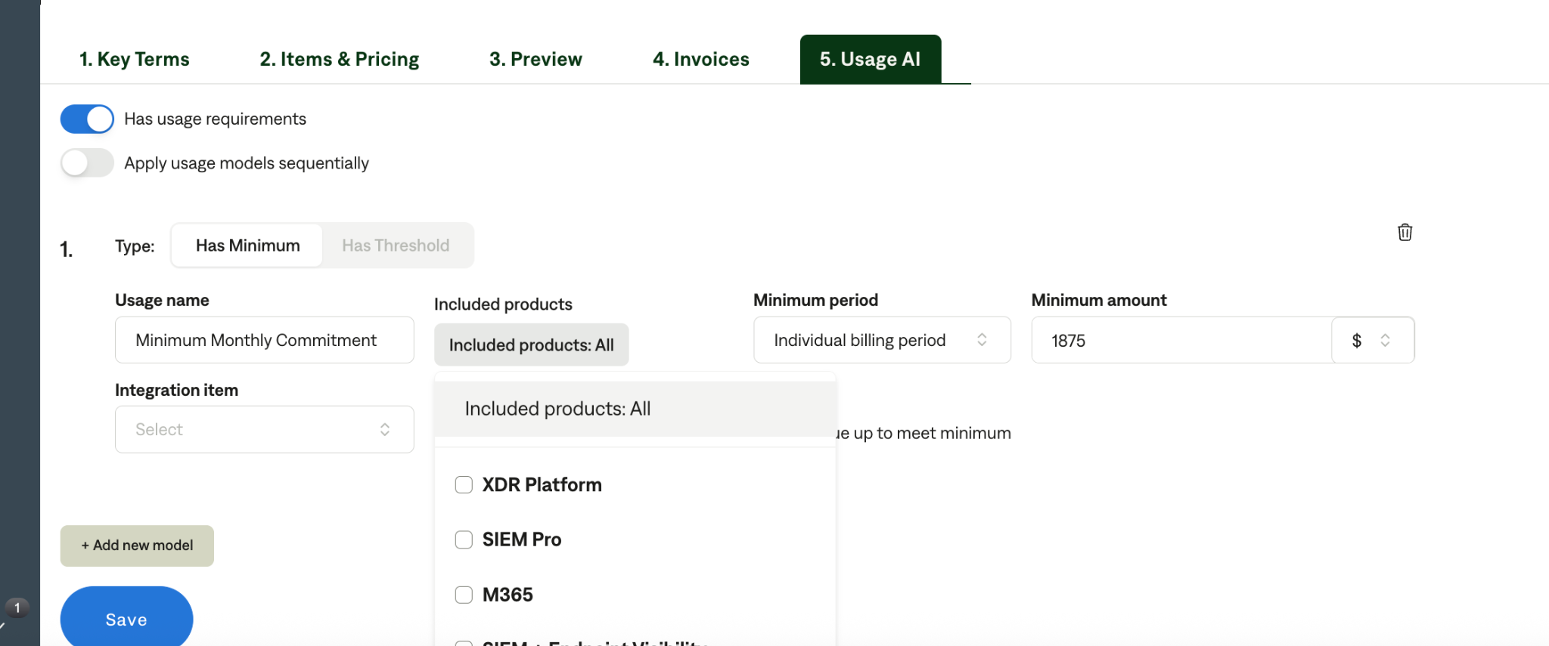

* + Minimum period: “individual billing period”
  + Minimum amount: use the amount listed under the Minimum Monthly Commitment column
  + Select “true up to meet minimum”
  + example:

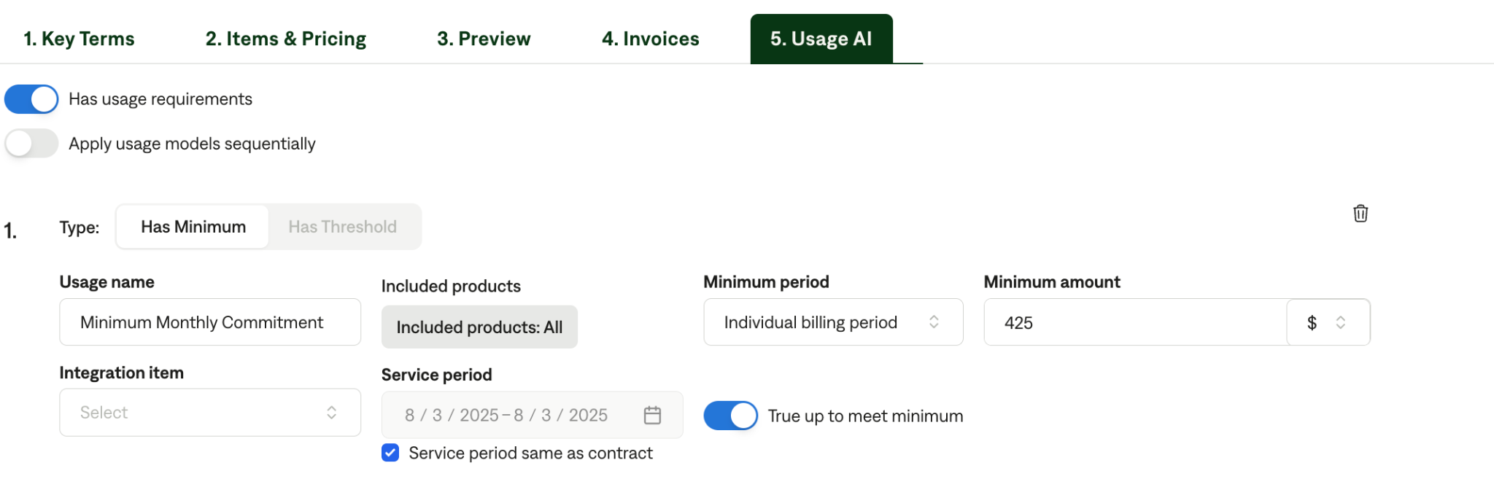

* Example Contracts

bc7ad7ce-27be-4714-b3e3-be07fec0f905

* ~~Old example contracts (need to be updated bc they don’t reflect in-line discounts)~~
  + ~~0742b675-aaed-42d5-9e36-cdaf8260624d~~
  + ~~F8ea5e6c-bb35-4291-8b7f-abea53ab6bb1~~
  + ~~C090ce68-a311-44f1-a444-46e19e96827a~~
  + ~~3eaf8da0-25a5-4ee3-990b-a23ec220f497~~
  + ~~6bd37524-6524-4a69-962e-e7b69bc3165d~~
  + ~~947453d0-98fa-4c01-ad87-786b245a8e7b~~

### Services

1. **Revenue Schedule**
   1. Use the “start date” listed at the top of the contract



1. **Months of Service**
   1. Use number of months that gets you from the “start date” to the “end date”
2. **Item Name**
   1. Use the name of the row e.g. “Blumira’s SIEM+ Edition” and “Additional Blumira Agents”
3. **Item Description**
   1. Not necessary
4. **Quantity**
   1. List # of licenses
5. **Billing Type**
   1. Flat
6. **Total Price**
   1. Use the “annual cost” and apply the discount to get to the “total cost”
7. **Billing Start Date**
   1. Same as service start date
8. **Period**
   1. Based on term and frequency
9. **Frequency**
   1. Reference billing timing for the invoicing cadence (e.g. year for annual; 3 months for quarterly; 1 month for monthly)
10. **Net terms**
    1. Check if net terms are stated; if not, default to 30
11. **Billing Timing**
    1. Bill first of period

**Revenue Category & Integration Item Mapping**

Please map all products to a revenue category (column 2) based on their product name - this is **required, please don’t forget!!**

| **Product Name** | **Revenue Category** | **Integration Item Mapping** |
| --- | --- | --- |
| **Additional Agent** | Agent-add-on | Agent-add-on |
| **Additional agents** | Agent-add-on | Agent-add-on |
| **Additional Agents** | Agent-add-on | Agent-add-on |
| **Additional Agents** | Agent-add-on | Agent-add-on |
| **Additional Blumira Agents** | Agent-add-on | Agent-add-on |
| **Advanced** | Siem-endpoint-visibility | Siem-endpoint-visibility |
| **Advanced+ Agent MSP Bundle** | Siem-endpoint-visibility | Siem-endpoint-visibility |
| **Advanced Edition** | Siem-endpoint-visibility | Siem-endpoint-visibility |
| **Blumira Agent Add-on** | Blumira-agents | Blumira-agents |
| **Blumira Agent Add-On** | Blumira-agents | Blumira-agents |
| **Blumira Agents** | Blumira-agents | Blumira-agents |
| **Blumira Agents** | Blumira-agents | Blumira-agents |
| **Blumira SIEM+** | Siem+ | Siem+ |
| **Blumira SIEM+** | Siem+ | Siem+ |
| **Blumira SIEM & XDR** | Siem+ | Siem+ |
| **Blumira’s XDR Edition** | Xdr-platform | Xdr-platform |
| **Blumira XDR** | Xdr-platform | Xdr-platform |
| **Blumira XDR** | Xdr-platform | Xdr-platform |
| **Cloud Edition** | Cloud-edition | Cloud-edition |
| **Credit for SIEM+ license fee adjustment** | Credit | Credit |
| **Expansion Services** | Expansion-services | Expansion-services |
| **Expansion Services** | Expansion-services | Expansion-services |
| **License Tier** | License-tier | License-tier |
| **License Tier** | License-tier | License-tier |
| **M365** | M365 | M365 |
| **M365\*\*** | M365 | M365 |
| **Microsoft 365 Edition** | M365 | M365 |
| **Onboarding Fee** | Onboarding-fee | Onboarding-fee |
| **SIEM+** | Siem+ | Siem+ |
| **SIEM Core** | Siem-core | Siem-core |
| **SIEM + Endpoint Visibility** | Siem-endpoint-visibility | Siem-endpoint-visibility |
| **SIEM + Endpoint Visibility\*** | Siem-endpoint-visibility | Siem-endpoint-visibility |
| **SIEM + Endpoint Visibility (formerly Advanced+)** | Siem-endpoint-visibility | Siem-endpoint-visibility |
| **SIEM Pro** | Siem-pro | Siem-pro |
| **SIEM Pro** | Siem-pro | Siem-pro |
| **XDR Platform** | Xdr-platform | Xdr-platform |
| **XDR Platform\*** | Xdr-platform | Xdr-platform |

1. Anything to ignore in contracts?
2. Specifics processing things the merchant has requested that may differ by contract (e.g. always back-date invoice date to final day of the month)
3. Default Service Term
   1. If None Listed, Ops Default is 1 Year
4. Default Net Payment Terms
   1. If None, Ops Default is 0
5. Default Billing Frequency
   1. If None Listed, Ops Default is Monthly
6. How do we handle taxes as a line item?
   1. If None Listed, Ops Default is every tax line item becomes a BT

### Events Processing (if necessary) *(Entire Section: Implementation/Success to fill Post-Go Live)*

* Any important information on events billing

Integration Items Processing (if necessary)  
*(Entire Section: Implementation/Success to fill Post-Go Live)*

* What are the instructions for assigning integration items?
* Example: All Statsig integrations items should be labeled as “Sales”
* Example: All “Pinata” integration items should be labeled as “Software Subscription Bundle” unless otherwise noted by Merchant

Post Processing Communications (if necessary)  
*(Entire Section: Implementation/Success to fill Post-Go Live)*

* Does the Ops Team need to notify anyone on the team re: completion of processing batches in Implementation or Active phase?
* Who needs to be notified and when?
  + Example:
    - Who: Customer Success [Azmat Aziz] needs to be notified
    - Where: Messari internal merchant channel
    - When: contracts are processed [Merchant Phase: Active]

### Customer Information *(Entire Section: Implementation/Success to fill Post-Go Live)*

* Any important information on specifics customers of this merchant
  + Special memo’s certain invoices require
  + Invoice changes due to merchant/customer relationship

### Feature Requests *(AE to fill for all requests prior to Imp handoff, Imp to fill prior to go-live/Success to fill to fill Post-Go Live)*

* Campfire Integration
  + Integration with Campfire (their ERP)
  + John, CEO at Campfire sent them to us. We have been abundantly clear that we do not have an integration with Campfire and they’re aligned on the manual upload of data. However, this would unlock a ton of value for a high ACV deal
  + Medium
* Usage AI
  + Saw Usage API in Beta and are going to strictly use this to pipe in usage data
  + Perfect world is sending all usage data via the API
  + High

### §Merchant Calls *(AE to fill for all videos prior to Imp involvement, Imp to fill prior to go-live/Success to fill to fill Post-Go Live)*

* Disco (7/7)
  + <https://us-56595.app.gong.io/call?id=7151020338768140830>
* Demo and Custom Demo (7/10)
  + <https://us-56595.app.gong.io/call?id=1803217848223949818>
* HubSpot Review (7/15)
  + <https://us-56595.app.gong.io/call?id=4471441326444540804>
* Partnership and Implementation (7/15)
  + <https://us-56595.app.gong.io/call?id=364848148786322178>